 INDIAN GENERAL ELECTIONS RESULT ANALYSIS 2024

1. **Total Seats?**

select DISTINCT COUNT(PARLIAMENT_CONSTITUENCY) AS Total_Seats

from constituencywise_results;

**O/P:**

1. **What is the total number of seats available for elections in each state ?**

SELECT

s.STATE AS State_name,

COUNT(DISTINCT cr.PARLIAMENT_CONSTITUENCY) AS Total_Seats

FROM constituencywise_results cr

INNER JOIN statewise_results sr

ON cr.PARLIAMENT_CONSTITUENCY = sr.PARLIAMENT_CONSTITUENCY

INNER JOIN states s

ON sr.state_id = s.state_id

GROUP BY s.STATE

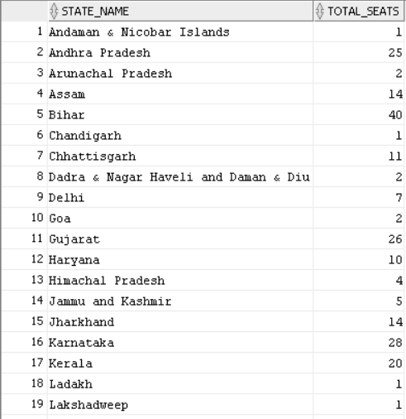ORDER BY STATE_NAME;

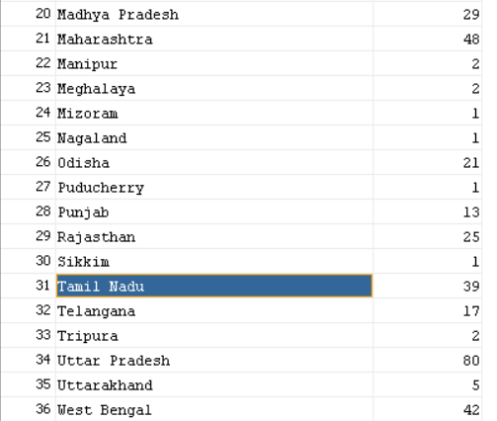

1. **Total Seats Won by NDA Allianz ?**

Select

Sum( CASE

WHEN PARTY IN('Bharatiya Janata Party - BJP',

'Telugu Desam - TDP',

'Janata Dal (United) - JD(U)',

'Shiv Sena - SHS',

'AJSU Party - AJSUP',

'Apna Dal (Soneylal) - ADAL',

'Asom Gana Parishad - AGP',

'Hindustani Awam Morcha (Secular) - HAMS',

'Janasena Party - JnP',

'Janata Dal (Secular) - JD(S)',

'Lok Janshakti Party(Ram Vilas) - LJPRV',

'Nationalist Congress Party - NCP',

'Rashtriya Lok Dal - RLD',

'Sikkim Krantikari Morcha - SKM'

) THEN "WON"

ELSE 0

END) AS NDA_TOTAL_SEATS_WON

FROM

partywise_results;



1. **Seats Won by NDA Allianz Parties?**

select

PARTY AS Party_Name,

WON as Seats_Won

from partywise_results

where PARTY IN(

'Bharatiya Janata Party - BJP',

'Telugu Desam - TDP',

'Janata Dal (United) - JD(U)',

'Shiv Sena - SHS',

'AJSU Party - AJSUP',

'Apna Dal (Soneylal) - ADAL',

'Asom Gana Parishad - AGP',

'Hindustani Awam Morcha (Secular) - HAMS',

'Janasena Party - JnP',

'Janata Dal (Secular) - JD(S)',

'Lok Janshakti Party(Ram Vilas) - LJPRV',

'Nationalist Congress Party - NCP',

'Rashtriya Lok Dal - RLD',

'Sikkim Krantikari Morcha - SKM')

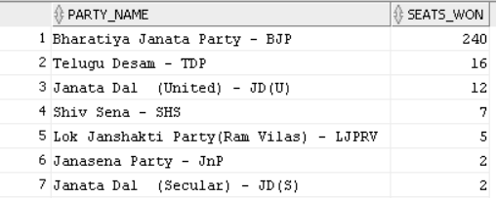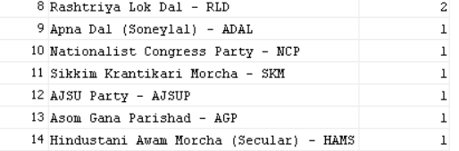 order by seats_won DESC;

1. **Total Seats Won by I.N.D.I.A. Allianz?**

SELECT

SUM(CASE

WHEN PARTY IN( 'Indian National Congress - INC',

'Aam Aadmi Party - AAAP',

'All India Trinamool Congress - AITC',

'Bharat Adivasi Party - BHRTADVSIP',

'Communist Party of India (Marxist) - CPI(M)',

'Communist Party of India (Marxist-Leninist) (Liberation) - CPI(ML)(L)',

'Communist Party of India - CPI',

'Dravida Munnetra Kazhagam - DMK',

'Indian Union Muslim League - IUML',

'Jharkhand Mukti Morcha - JMM',

'Jammu & Kashmir National Conference - JKN',

'Kerala Congress - KEC',

'Marumalarchi Dravida Munnetra Kazhagam - MDMK',

'Nationalist Congress Party Sharadchandra Pawar - NCPSP',

'Rashtriya Janata Dal - RJD',

'Rashtriya Loktantrik Party - RLTP',

'Revolutionary Socialist Party - RSP',

'Samajwadi Party - SP',

'Shiv Sena (Uddhav Balasaheb Thackrey) - SHSUBT',

'Viduthalai Chiruthaigal Katchi - VCK'

) THEN "WON"

ELSE 0

END) AS INDIA_Total_Seats_Won

From

Partywise_results;



1. **Seats Won by I.N.D.I.A. Allianz Parties**

select

PARTY AS Party_Name,

WON AS Total_seats_won

from Partywise_results

WHERE PARTY IN ('Indian National Congress - INC',

'Aam Aadmi Party - AAAP',

'All India Trinamool Congress - AITC',

'Bharat Adivasi Party - BHRTADVSIP',

'Communist Party of India (Marxist) - CPI(M)',

'Communist Party of India (Marxist-Leninist) (Liberation) - CPI(ML)(L)',

'Communist Party of India - CPI',

'Dravida Munnetra Kazhagam - DMK',

'Indian Union Muslim League - IUML',

'Jammu & Kashmir National Conference - JKN',

'Jharkhand Mukti Morcha - JMM',

'Kerala Congress - KEC',

'Marumalarchi Dravida Munnetra Kazhagam - MDMK',

'Nationalist Congress Party Sharadchandra Pawar - NCPSP',

'Rashtriya Janata Dal - RJD',

'Rashtriya Loktantrik Party - RLTP',

'Revolutionary Socialist Party - RSP',

'Samajwadi Party - SP',

'Shiv Sena (Uddhav Balasaheb Thackrey) - SHSUBT',

'Viduthalai Chiruthaigal Katchi - VCK')

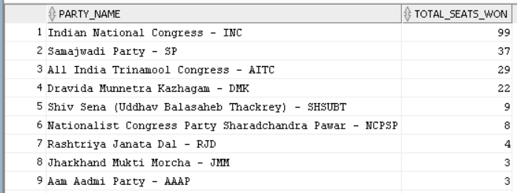ORDER BY WON DESC;

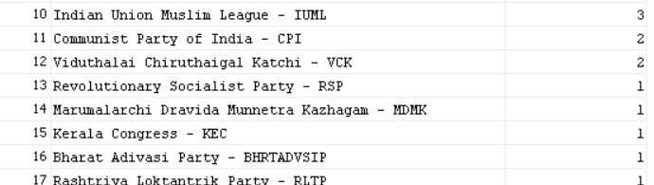

1. **Add new column field in table partywise_results to get the Party Allianz as NDA, I.N.D.I.A and OTHER**

Alter table partywise_results ADD PARTY_ALLIANCE VARCHAR(50);

--- NDA Allianz ---

UPDATE partywise_results SET PARTY_ALLIANCE = 'NDA' WHERE PARTY IN ('Bharatiya Janata Party - BJP',

'Telugu Desam - TDP',

'Janata Dal (United) - JD(U)',

'Shiv Sena - SHS',

'AJSU Party - AJSUP',

'Apna Dal (Soneylal) - ADAL',

'Asom Gana Parishad - AGP',

'Hindustani Awam Morcha (Secular) - HAMS',

'Janasena Party - JnP',

'Janata Dal (Secular) - JD(S)',

'Lok Janshakti Party(Ram Vilas) - LJPRV',

'Nationalist Congress Party - NCP',

'Rashtriya Lok Dal - RLD',

'Sikkim Krantikari Morcha - SKM'

);

---- I.N.D.I.A Allianz ----

UPDATE partywise_results SET party_alliance = 'I.N.D.I.A'

WHERE PARTY IN ('Indian National Congress - INC',

'Aam Aadmi Party - AAAP',

'All India Trinamool Congress - AITC',

'Bharat Adivasi Party - BHRTADVSIP',

'Communist Party of India (Marxist) - CPI(M)',

'Communist Party of India (Marxist-Leninist) (Liberation) - CPI(ML)(L)',

'Communist Party of India - CPI',

'Dravida Munnetra Kazhagam - DMK',

'Indian Union Muslim League - IUML',

'Jammu & Kashmir National Conference - JKN',

'Jharkhand Mukti Morcha - JMM',

'Kerala Congress - KEC',

'Marumalarchi Dravida Munnetra Kazhagam - MDMK',

'Nationalist Congress Party Sharadchandra Pawar - NCPSP',

'Rashtriya Janata Dal - RJD',

'Rashtriya Loktantrik Party - RLTP',

'Revolutionary Socialist Party - RSP',

'Samajwadi Party - SP',

'Shiv Sena (Uddhav Balasaheb Thackrey) - SHSUBT',

'Viduthalai Chiruthaigal Katchi - VCK');

select * from partywise_results;

UPDATE partywise_results SET party_alliance = 'OTHERS' WHERE party_alliance IS NULL;

1. **Which party alliance (NDA, I.N.D.I.A, or OTHER) won the most seats across all states?**

SELECT

party_alliance,

SUM(WON) AS SEATS_WON

from partywise_results

GROUP BY party_alliance

ORDER BY SEATS_WON DESC;

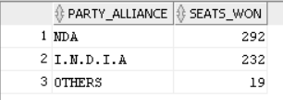

1. **Winning candidate's name, their party name, total votes, and the margin of victory for a specific state and constituency?**

SELECT cr.Winning_Candidate, p.Party, p.party_alliance, cr.Total_Votes, cr.Margin, cr.Constituency_Name, s.State

FROM constituencywise_results cr

JOIN partywise_results p ON cr.Party_ID = p.Party_ID

JOIN statewise_results sr ON cr.Parliament_Constituency = sr.Parliament_Constituency

JOIN states s ON sr.State_ID = s.State_ID

WHERE cr.Constituency_Name = 'COIMBATORE';



1. **What is the distribution of EVM votes versus postal votes for candidates in a specific constituency?**

SELECT

cd.Candidate,

cd.Party,

cd.EVM_Votes,

cd.Postal_Votes,

cd.Total_Votes,

cr.Constituency_Name

FROM

constituencywise_details cd

JOIN

constituencywise_results cr ON cd.Constituency_ID = cr.Constituency_ID

WHERE

cr.Constituency_Name = 'COIMBATORE'

ORDER BY cd.Total_Votes DESC;

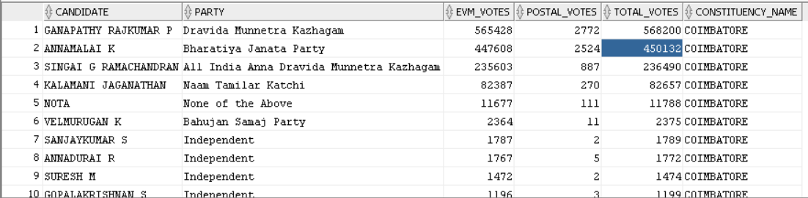

1. **Which parties won the most seats in s State, and how many seats did each party win?**

SELECT

p.Party,

COUNT(cr.Constituency_ID) AS Seats_Won

FROM

constituencywise_results cr

JOIN

partywise_results p ON cr.Party_ID = p.Party_ID

JOIN

statewise_results sr ON cr.Parliament_Constituency = sr.Parliament_Constituency

JOIN states s ON sr.State_ID = s.State_ID

WHERE

s.state = 'Tamil Nadu'

GROUP BY

p.Party

ORDER BY

Seats_Won DESC;

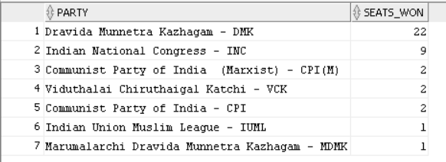

1. **What is the total number of seats won by each party alliance (NDA, I.N.D.I.A, and OTHER) in each state for the India Elections 2024?**

SELECT

s.State AS State_Name,

SUM(CASE WHEN p.party_alliance = 'NDA' THEN 1 ELSE 0 END) AS NDA_Seats_Won,

SUM(CASE WHEN p.party_alliance = 'I.N.D.I.A' THEN 1 ELSE 0 END) AS INDIA_Seats_Won,

SUM(CASE WHEN p.party_alliance = 'OTHER' THEN 1 ELSE 0 END) AS OTHER_Seats_Won

FROM

constituencywise_results cr

JOIN

partywise_results p ON cr.Party_ID = p.Party_ID

JOIN

statewise_results sr ON cr.Parliament_Constituency = sr.Parliament_Constituency

JOIN

states s ON sr.State_ID = s.State_ID

WHERE

p.party_alliance IN ('NDA', 'I.N.D.I.A', 'OTHER') -- Filter for NDA and INDIA alliances

GROUP BY

s.State

ORDER BY

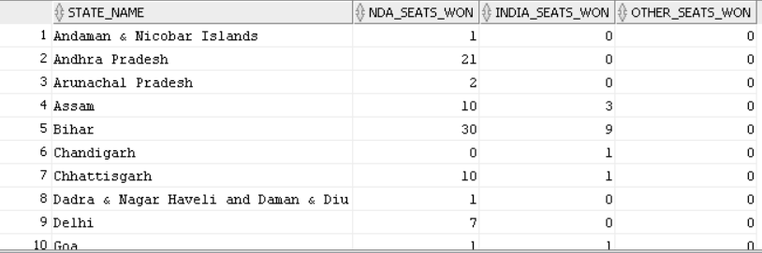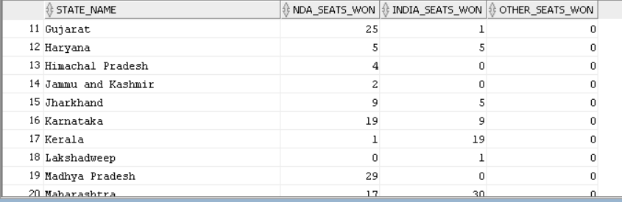 s.State;

1. **Which candidate received the highest number of EVM votes in each constituency (Top 10)?**

select

cd.CANDIDATE,

cr.CONSTITUENCY_NAME,

cd.PARTY,

cd.EVM_VOTES

from constituencywise_details cd INNER JOIN constituencywise_results cr ON cd.CONSTITUENCY_ID = cr.CONSTITUENCY_ID

WHERE cd.EVM_VOTES=(select MAX(cd.EVM_VOTES) from constituencywise_details cd where cd.CONSTITUENCY_ID = cr.CONSTITUENCY_ID)

ORDER BY EVM_VOTES DESC

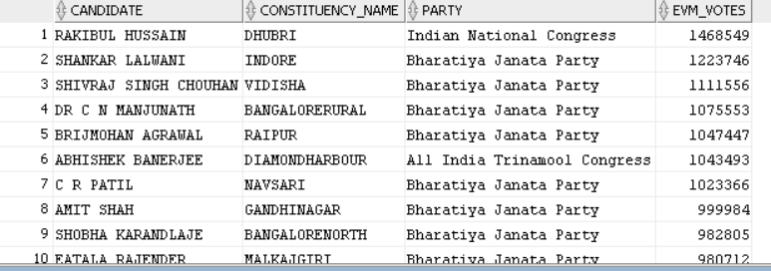FETCH FIRST 10 ROWS ONLY;

1. **Which candidate won and which candidate was the runner-up in each constituency of State for the 2024 elections?**

WITH RankedCandidates AS (

SELECT

cd.Constituency_ID,

cd.Candidate,

cd.Party,

cd.EVM_Votes,

cd.Postal_Votes,

cd.EVM_Votes + cd.Postal_Votes AS Total_Votes,

ROW_NUMBER() OVER (PARTITION BY cd.Constituency_ID ORDER BY cd.EVM_Votes + cd.Postal_Votes DESC) AS VoteRank

FROM

constituencywise_details cd

JOIN

constituencywise_results cr ON cd.Constituency_ID = cr.Constituency_ID

JOIN

statewise_results sr ON cr.Parliament_Constituency = sr.Parliament_Constituency

JOIN

states s ON sr.State_ID = s.State_ID

WHERE

s.State = 'Tamil Nadu'

)

SELECT

cr.Constituency_Name,

MAX(CASE WHEN rc.VoteRank = 1 THEN rc.Candidate END) AS Winning_Candidate,

MAX(CASE WHEN rc.VoteRank = 2 THEN rc.Candidate END) AS Runnerup_Candidate

FROM

RankedCandidates rc

JOIN

constituencywise_results cr ON rc.Constituency_ID = cr.Constituency_ID

GROUP BY

cr.Constituency_Name

ORDER BY

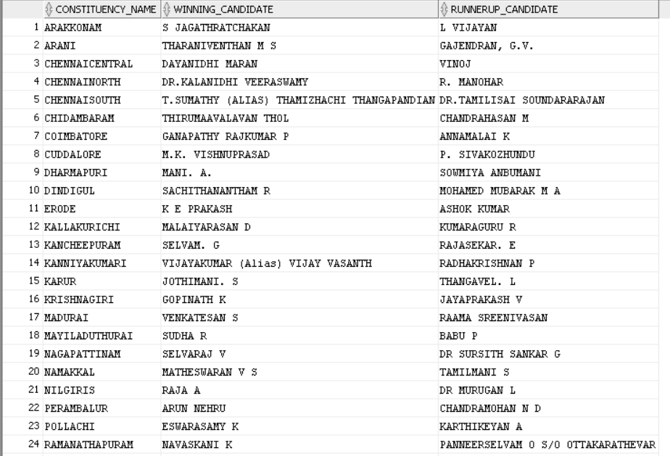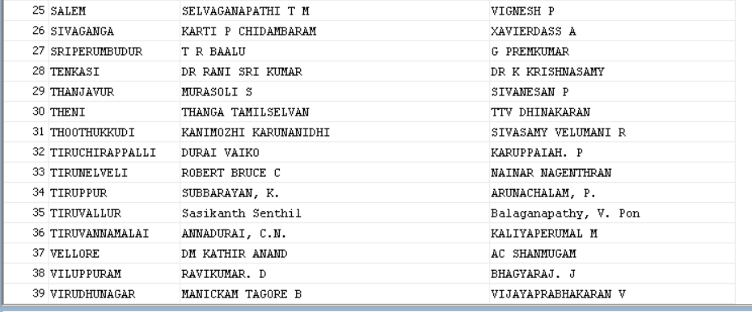 cr.Constituency_Name;